In week 8, the team had another playtest on Thursday with middle school students. Before the playtest, we made some changes from the prior playtest.

**Game Updated**

We create the tutorial part to introduce the basic game UI and mechanics at the beginning of the game. Because many players show their confusion to our game menu and UI. We design and implement a complete tutorial at the beginning.

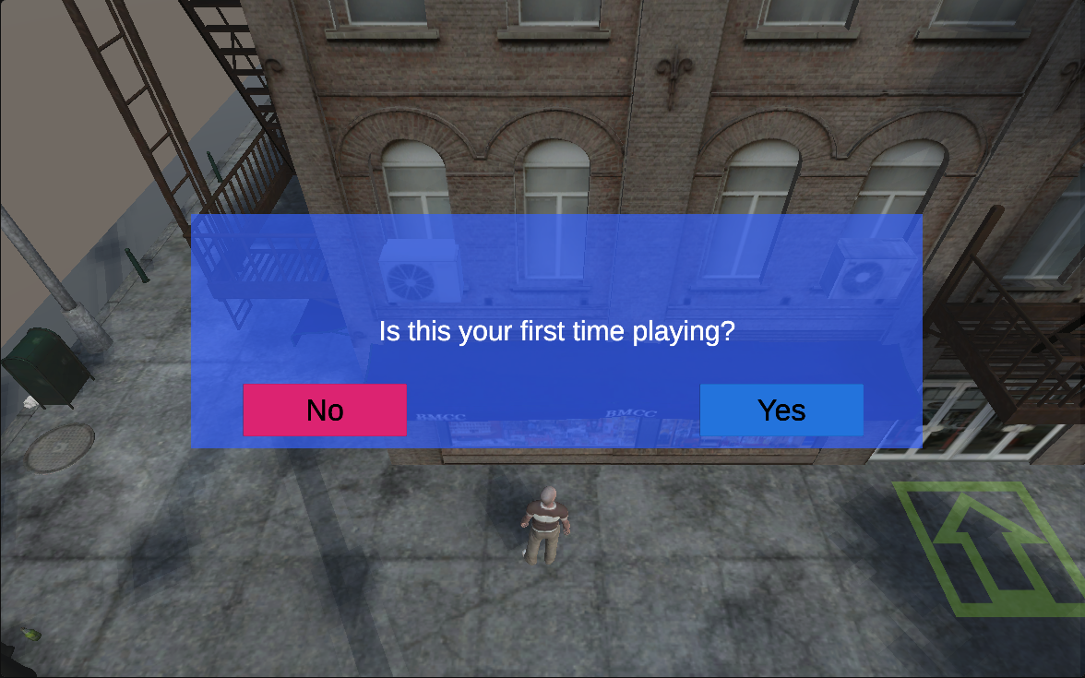

During the gameplay, we also added instruction with the game flow to introduce some important Game Icons and UI pages. We designed and implemented those instructions within the Uncle’s dialogue to create a nature and fluent communication.

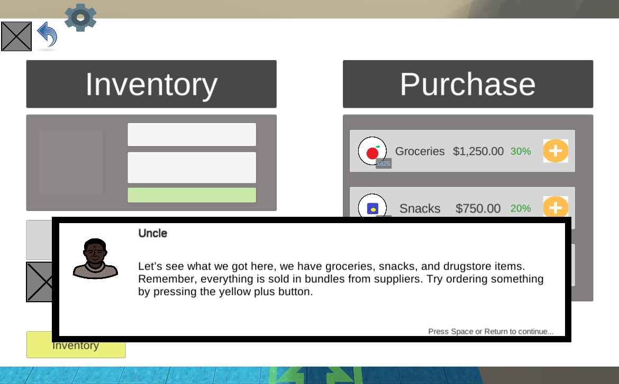

**Playtest feedbacks**

The playtest was held from 2PM to 3PM on Thursday. We wanted to test our in-Game instructions and tutorial so that we didn’t introduce the game at the beginning.

Generally, the instructions and tutorial worked very well to introduce the game features. Players can easily find where to go and what to do. We were very happy to see our effort making a better result!

On the other hand, we did receive feedback for details.

For example, they want the text scroll faster to save more time in reading the dialogue. Also, they give us valuable suggestions to improve our game scene.

Week 8 is a very productive week for us. We iterated our game design based on last week's suggestions and made our game playable for Thursday's playtest.